Setting Up Application Environment

**Install IBM Cloud CLI**

|  |  |
| --- | --- |
| Team ID | PNT2022TMID50137 |
| Project Name | Smart Fashion Recommender Application |
| Team Members: | Gokul S  Jesu Denison K  John Prakash I  John Stephen J |

# Step 1:

Login to your IBM Cloud [***https://cloud.ibm.com/login***](https://cloud.ibm.com/login) and in-search bar you can type

**Container registery** and click to get started.

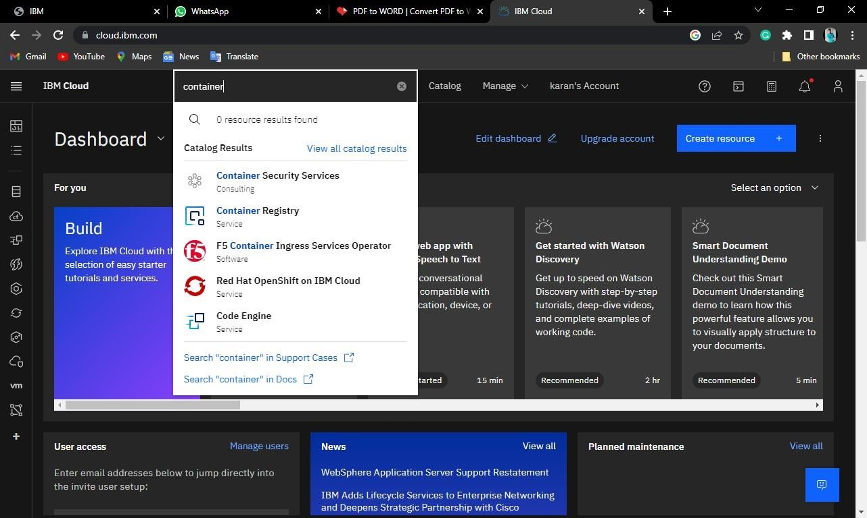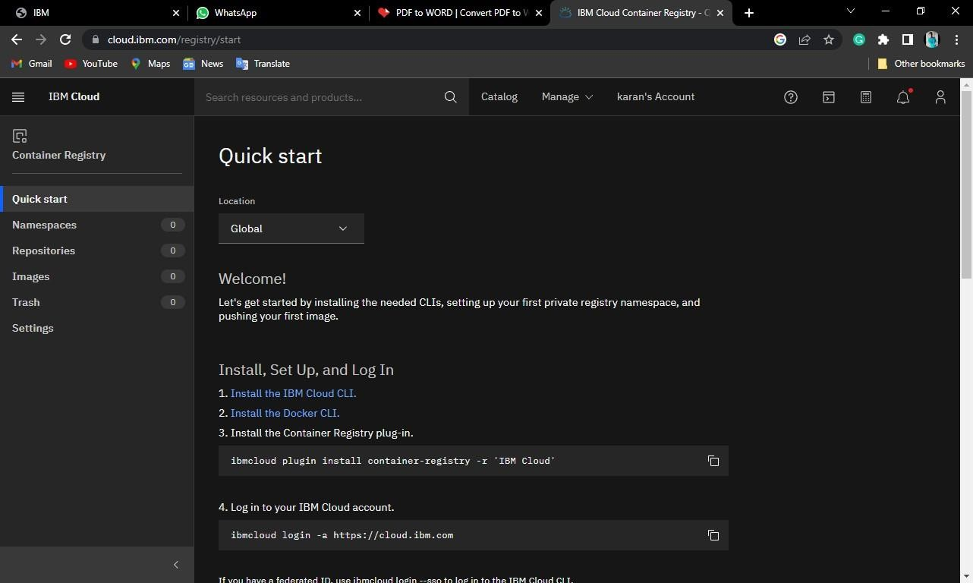

# Step 2:

Follow and do the step given in this page one by one [***https://cloud.ibm.com/registry/***](https://cloud.ibm.com/registry/%20start)

[start](https://cloud.ibm.com/registry/%20start)

# Step 3:

Run the command in power shell,

(New-Object Net.WebClient).DownloadString('https://clis.cloud.ibm.com

/install/powershell')

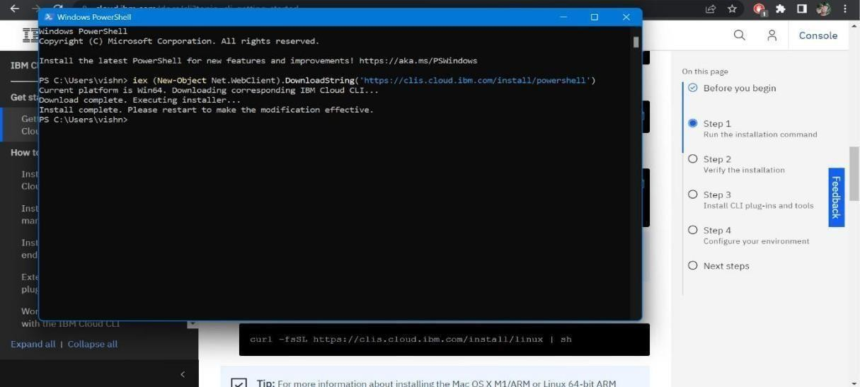

# Step 4:

Enter the command in cmd:

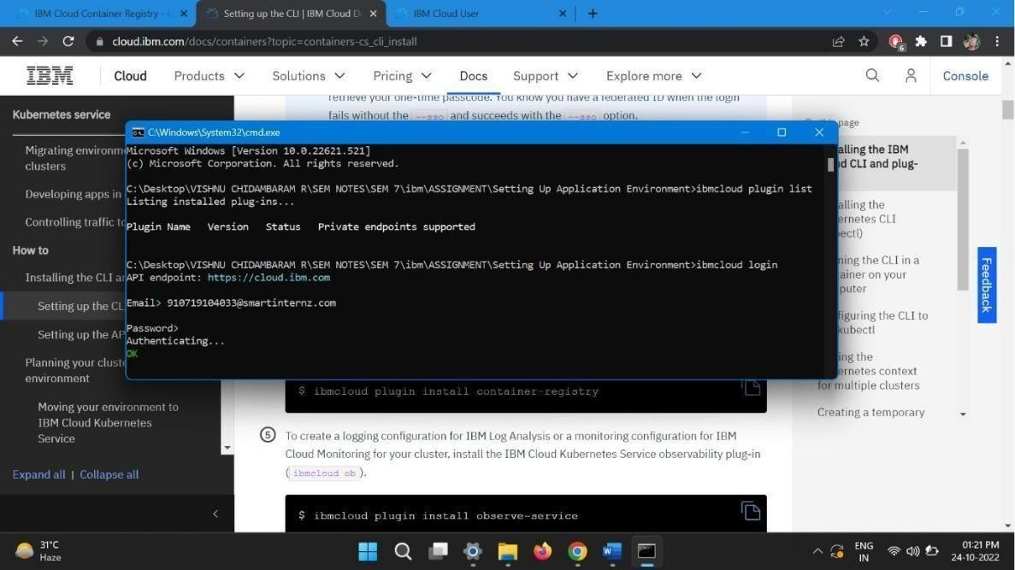

# Step 5:

Run all the command one by one in cmd

<https://cloud.ibm.com/docs/containers?topic=containers-cs_cli_install>

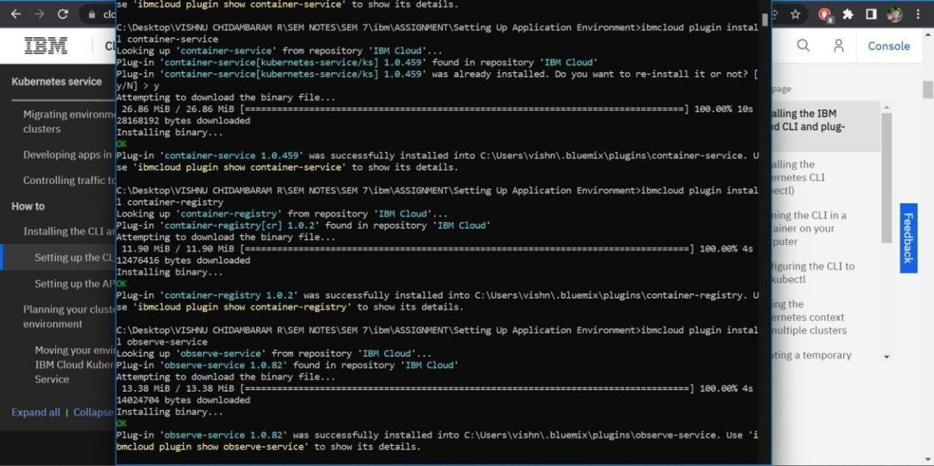

# Step 6:

Finally, you will get the IBM CLOUD CLI in your desktop.